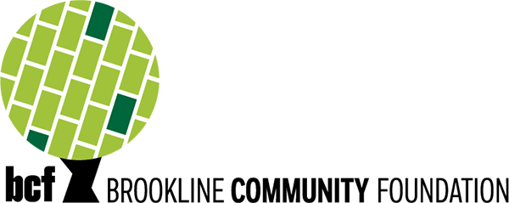

Sponsorship Request Form

The Brookline Community Foundation (BCF) is committed to fostering inclusivity and equity in the Brookline community. BCF is dedicated to supporting a vibrant and diverse cultural ecosystem and promoting community well-being through transformative investments in organizations and community efforts.
BCF aims to continue to support community groups and organizations that promote diversity and foster a sense of connection and celebration in the community through our new Culturally Immersive Event Sponsorships.
If you wish to apply for a sponsorship, please complete the form below and submit it via email to grants@brooklinecommunity.org for consideration.
Name of Organization:
Name of Event:
Date of Event:
Organization Contact:
Contact Phone:
Contact Email:
Amount Requested:

Please send us any sponsorship materials (i.e. invitation, sponsorship packet, ad information, etc.)

